**PCB 4674 Evolution**  July 18, 2016

**Lab # 10: Sexual Selection**

**SEXUAL SELECTION**

Reference chapters (in textbook): Ch. 11

**Lab objectives:**

* Using guppy fish case study to understand sexual selection in nature.

1. **Guppy Simulation**

Most of us know guppies only as dramatically patterned aquarium fish (Figure 1). But the domesticated guppies we see in fish tanks are descended from wild ancestors. Wild guppies, *Poecilia reticulate*, live in mountain streams in the tropical forests of northeastern Venezuale, Margarita Island, Trinidad, and Tobago (Figure 2). Wild female guppies, like their domesticated cousins, are silvery gray and inconspicuous (Figure 3, left ones). Wild males, whole not so extravagantly ornamented as the males you see in pet stores, are nonetheless impressively showy (Figure 3, center and right ones). They wear stripes, spots, and splashes of color that can be orange, yellow, black, blue or iridescent. No two males are exactly alike.

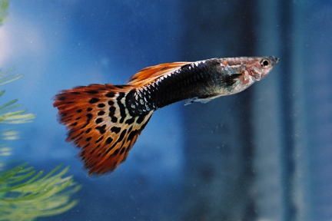 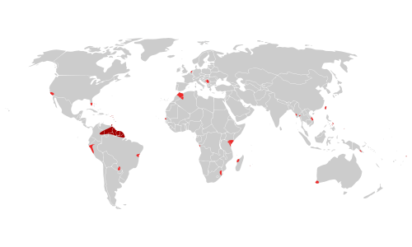

Figure 1. Red dragon guppy Figure 2. Dark red indicates the native range of guppies

Professor John Endler traveled to Trinidad in the 1970s to study wild guppies. The guppy populations there live in small streams that flow down the mountains from pool to pool. In this activity, you will take part in an online simulation of Endler’s work. You will collect data, formulate a hypothesis, and run a series of experiments. You will find out about the interplay between natural selection and sexual selection in this wild population of guppies.

1. Launch the “Sex and the Single Guppy” Web activity (http://www.pbs.org/wgbh/evolution/sex/guppy/).

There is a link in the top left corner of the page that says “low bandwidth version” you should click this if the original website says you need a plug-in.

1. Select "I'm ready to find out."
2. Read the text, and click on the pools to investigate the guppy stream more closely.

**If being flashy attracts predators, why are male guppies so colorful?**

Male guppies are so colorful because they need to reproduce, even though they are more susceptible to predation. If the guppy is very bright and flashy, more females will be attracted to him

**What do you think is responsible for the variation in color from one generation to the next?**

No two guppies are the same. This is because guppy fish reproduce sexually. The offspring genes cross over and recombine to form new color variations. This can also be due to many males mating with many females, so we have a greater possibility of genetic variation.

1. Then click on "What causes guppy color variation?" Select one of the hypotheses.

I chose this hypothesis: “Predators are causing guppy populations to become more drab by preying on the most brightly colored individuals and eliminating them from the gene pool.”

**Can you think any other hypotheses?**

Brightly colored guppies are more likely to be eaten, so we will see an even number of drab colored guppies in low/medium predated lakes/rivers/streams and brightly colored guppies.

1. Visit the Guppy Gallery. Read about the different types of guppies, their predators, and their habitats.

Rivulus are only able to eat juvenile guppies, while pike cichlids and blue acara are able to prey on adults

1. Click on "simulation." Proceed with the simulation by creating and carrying out a “field” experiment to gather data to test your hypothesis.

**Record your initial settings here:**

Predator types and numbers: 30 rivulus Initial guppy population: 100

**Run your initial experiment for at least five generations and record your results here:**

Number of guppies: 227 Number of generations: 5

Number of weeks: 112

Male color types:

Bright male guppy _42___% Brightest male guppy _7___%

Drab male guppy _18___% Drabbest male guppy _34___%

**Was your hypothesis supported by your data? If so, why? If not, you may want to change your hypothesis and rerun your experiment.**

Yes, it was supported because the brightly colored fish and drab fish were even in a low/medium predation environment.

New hypothesis: Drabbest fish will become high over time in a high predation environment

**Record your initial settings here:**

Predator types and numbers: 30 rivulus, 30 acara, 30 cichlids

Initial guppy population: 100

Number of guppies: 171 Number of generations: 4

Number of weeks: 57

Male color types:

Bright male guppy _15___% Brightest male guppy __9__%

Drab male guppy _26___% Drabbest male guppy _50___%

Was the newest hypothesis supported by your data now? If so, why? If not, redo.

Yes, it was supported. With high predation brightly colored guppies were consumed in higher rates than drab guppies. Overtime in high predation environments there will be higher percentage of drab fish, since they will be able to reproduce.

Now, try to summarize what you learned from your experiments.

**Why do some guppies tend to be drabber than others?**

When fish consume brightly colored guppy, the drab guppies are camouflaged so they are able to survive and reproduce. Not all guppies can be brightly colored, because in high predation environments, if no drab guppies existed, then the predators might consume all the males.

**Why do some guppies tend to be more colorful?**

It is very likely that brightly colored guppies can indicate that they have beneficial genes, such as strength or swiftness. If the brightly colored guppy has survived this long to mate, then he must be fit.

**What role does color play in guppy survival?**

Brightly colored guppies are more likely to be consumed by predators but drab colored guppies are less likely to find mates if brightly colored guppies are present.

**Explain the push and pull that the environment has on the coloration of guppies in Endler’s pools.**

Guppies must survive to attract mates. Females are attracted to the brightly colored guppies, so there will always be guppies with bright colors. This sexual selection forces guppies to be more colorful, which predation forces guppies to be more drab.

1. **Dr. John Endler’s Experiment**

In 1980 John Endler published the results of two experiments on guppies that are now considered classics. Endler had examined numerous guppies from each of several natural streams. He found that the males in some locations had many more spots, on average, than the males in other populations.

Endler’s hypothesis was that predators are responsible for much of this variation among populations. He had noticed that guppies sharing their stream with predatory cichlids had fewer spots than guppies living with Rivulus. Cichlids are ravenous predators of adult guppies. Rivulus eat only juvenile guppies.

In his first experiment, Endler collected guppies from 18 locations in 11 different streams. He moved these fish into artificial ponds in a greenhouse, and let them grow for about 6 months—long enough for several generations of fish to grow up, reproduce, and die. Endler then divided his guppy population among 10 greenhouse ponds. To four ponds he added a single cichlid. To four other ponds he added half a dozen Rivulus. The remaining two ponds he left without predators as controls. Five months later, and again 14 months later, Endler sampled male guppies from his ten populations and counted their spots. Here are Endler’s actual results. Please examine the graph.



Results from Endlers’ greenhouse experiment: Endler established his guppy population at month zero. At month six, he divided his guppies among ten ponds with different predators. The graph shows the average number of spots per malein the founding population, the Rivulus ponds, the Cichlid ponds, and the predator-free ponds at 0, 6, 10 and 20 months. (Source: Re-rendered from Figure 1 in Endler 1980.)

**How do Endler’s results compare with your results? Was Endler’s hypothesis correct?**

My results were the same as Endlers. Endler’s hypothesis is correct. When Rivulus fish are introduced, there is a high number of spots on the fish because the predation is low and the spotted fish are able to reproduce. When the predation is high there is more chance for the non-spotted fish to reproduce.

In his second experiment, Endler sought to replicate his greenhouse results in the wild. Among the tributaries of the Aripo River in Trinidad, Endler found a guppy population living with cichlids, a guppy population living with Rivulus, and a stream that contained Rivulus, but no cichlids or guppies. Endler caught about 200 guppies from the population living with cichlids and moved them to the stream with Rivulus, but no guppies. He returned two years later to sample males from all three locations. Again, here are the actual results.



Results of Endler’s Field Experiment: The light gray bars show the average number of spots per fish at the end of the greenhouse experiment. The dark gray and black bars show the results from the transplantation experiment. (Source: Re-rendered from Figures 2 and 4 in Endler 1980.)

**How do Endler’s results compare with your results? Are the results from his field experiment consistent with the results from his greenhouse experiment?**

In the green-house experiment I predicted that the smallest spots would be found where the cichilids were present. This is because cichilidsp consume the most visible guppies. Guppies that have small spots do not stand out as much and have more success reproducing. In the article it said that the grain size had more of an effect on the size of the spots than the predators.